TRAINING REPORT
EMBEDDED C



SUBMITTED BY: DEEPANSH MADAN

EMP ID:213458

Contents
1 TABLE OF FIGURES 3
2 MODULE DESIGN AND IMPLEMENTATION OF WIPER SYSTEM 4
2.1 CIRCUIT DESIGN 4
2.2 SIMULATION RESULT 4
https://www.tinkercad.com/things/diPfzxvVoTy-wiper-system-shiny-migelo/editel?sharecode=obhJcuppSEly7eiN8WKtTH4HIzR4fJXjlMp8T5j6Xa4= 4
2.3 EMBEDDED C CODE USING API 5
3 ILLUSTRATE RISC AND CISC ARCHITECTURE 7
3.1 RISC 7
3.2 CISC 7
4 BLOCK DIAGRAM OF COFFEE VENDING MACHINE ECU AND ITS DESIGN CHALLENGE CHART 8
4.1 BLOCK DIAGRAM 8
5 VON- NEUMAN AND HARVARD ARCHITECTURE 9
6 ASSOCIATIVITY OF OPERATORS IN C LANGUAGE 10
7 RGB interfacing on Tinkercad 11
7.1 Circuit Design 11
7.2 Simulation Result 11
7.3 Code 11
8 Size of Serial Registers in Atmega 328P 12
9 Frames in Ethernet 12
10 Prescalar 12
11 Simulator and Emulator 12

TABLE OF FIGURES

Figure 1Wiper System Circuit 4
Figure 2Block Diagram of Coffee Vending Machine 8
Figure 3Design Challange Chart of Coffee Vending MachineDESIGN CHALLENGE CHART 8
Figure 4Associativity Table 10
Figure 5RGB Interfacing Circuit Diagram 11

MODULE DESIGN AND IMPLEMENTATION OF WIPER SYSTEM

CIRCUIT DESIGN

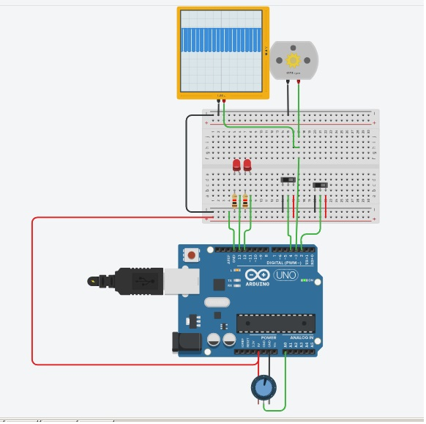
Figure 1Wiper System Circuit

SIMULATION RESULT
https://www.tinkercad.com/things/diPfzxvVoTy-wiper-system-shiny-migelo/editel?sharecode=obhJcuppSEly7eiN8WKtTH4HIzR4fJXjlMp8T5j6Xa4=

EMBEDDED C CODE USING API

- #define HIGH 1
- #define LOW 0
- int ignPin =2;
- int wipPin =4;
- int rainPin = A0;
- int ignLed = 13;
- int motorOut=3;
- int wipLed = 12;
- void setup()
- {
- Serial.begin(9600);
- pinMode(ignPin, INPUT);
- pinMode(wipPin, INPUT);
- pinMode(rainPin, INPUT);
- pinMode(motorOut, OUTPUT);
- pinMode(wipLed, OUTPUT);
- pinMode(ignLed, OUTPUT);
- digitalWrite (ignLed, LOW);
- digitalWrite (wipLed, LOW);
- analogWrite (motorOut,0);

- }
- int potent = 0;
- int PWM =0;
- void loop()
- {
- start:
- while ((digitalRead(ignPin))== HIGH) //ignition check
- {
- Serial.println("ignitionON");
- digitalWrite(ignLed,HIGH); //ignition LED

- if(digitalRead (wipPin) == HIGH){ //wiper check
- Serial.println("wiperON");

- digitalWrite(wipLed,HIGH);
- potent = analogRead(rainPin); //rainsens input

- if(potent >=5){ // IF RAIN >THRESHOLD
- PWM = map(potent,0,1023,5,255); // MAPPING FOR MOTOR
- if (PWM >= 5 && PWM< 80){
- analogWrite(motorOut,64);
- }
- else if(PWM>= 80 && PWM <160){
- analogWrite(motorOut,191);
- }
- else if(PWM>= 160 && PWM <=255){
- analogWrite(motorOut,255);
- }
- else {
- Serial.println("ERROR... mapping 03");
- goto start;
- }
- delay(5000);
- Serial.println("fault 1");
- goto start;

- }
- else if(potent <5){ // NO RAIN .. NO OUTPUT
- analogWrite(motorOut, 0);
- delay(5000);
- goto start;
- }
- else {
- Serial.println("ERROR.. rain detection 02");
- goto start;
- }
- }
- else if (digitalRead(wipPin)== LOW){
- Serial.println("wiperOFF");
- analogWrite(motorOut,0);
- digitalWrite(wipLed , LOW);
- goto start;
- }
- else{
- Serial.println ("ERROR 01 ");
- goto start;
- }
- }
- Serial.println("ignitionOFF");

- analogWrite(motorOut,0);
- digitalWrite(ignLed, LOW);
- digitalWrite(wipLed,LOW);
- }

ILLUSTRATE RISC AND CISC ARCHITECTURE

RISC
- RISC is an acronym for Reduced Instruction Set Code. Corresponds to basic hardware design where each small instruction is hard wired.
- Instructions are simple and short, and take an average time of 1 to 1.5 clocks per instruction.
- It has no memory unit to store complex instruction, complex software is written for high efficiency.
- Less number of instruction set which can be combined to perform various complex tasks.
- The architecture is heavily pipelined and multiple registers are present
- The code can be decoded easily and requires no external memory for performing ALU tasks.

CISC
- CISC is an acronym for Complex Instruction Set Code. It performs multiple simpler instructions within a single instruction thus making it a complex instruction set.
- Instructions are big and it takes an average of 2 to 15 clock cycles per instructions.
- It stores big instructions in memory units and hence the complexity is on the hardware side.
- Multiple instructions are present in different modes which can perform high level tasks very easily.
- The architecture is less flexible, less pipelined and more focused on delivering the output of specific task.

BLOCK DIAGRAM OF COFFEE VENDING MACHINE ECU AND ITS DESIGN CHALLENGE CHART

BLOCK DIAGRAM
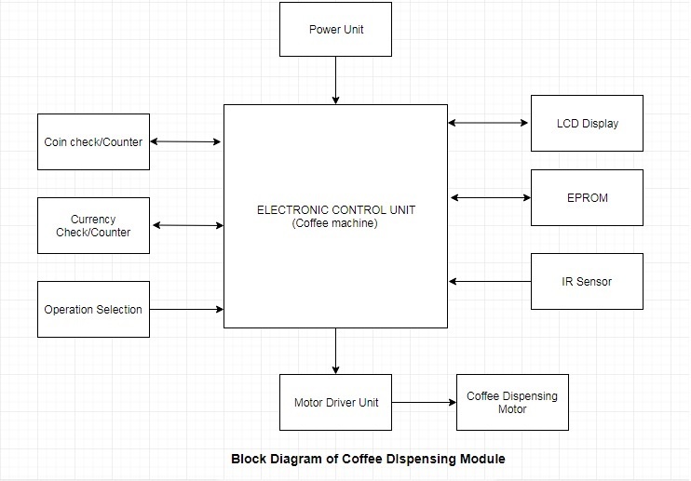
Figure 2Block Diagram of Coffee Vending Machine
Figure 3Design Challange Chart of Coffee Vending MachineDESIGN CHALLENGE CHART
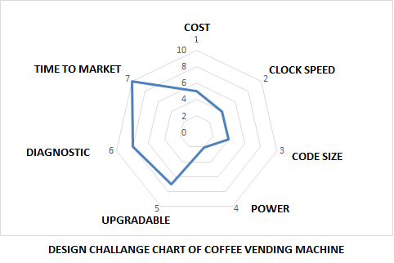

VON- NEUMAN AND HARVARD ARCHITECTURE

- VON-NEUMAN ARCHITECTURE
- Von- Neumann architecture is based on traditional design of storage of a software code, i.e. data and code is stored in a single physical memory in a continuous sequence.
- Processor requires multiple cycles to fetch (mostly 1 instruction), decode(mostly 1) , execute(1 or more) and store(1 or 2 ) the instruction.
- The number of cycles for each instruction is mostly same.
- Only one permanent memory is used to store code and data. In some architecture code is stored in the starting address followed by its corresponding data.
- While in others the starting address is a data (or vector address), which transfers the program control to initializing code.
- The architecture is simple and costs less.
- It has no pipelining and hence execution of instruction is slower but they are easy to handle.

- HARVARD ARCHITECTURE
- Harvard architecture or modern computer architecture is based on the concept of usage of different storage memories for data and code.
- Processor requires less number of cycles to complete one instruction i.e. fetch, decode, execute, storage.
- Steps like fetching, decode are processed in parallel or at same time, as data and code is stored at different places with separate buses for transfer of data
- The number of cycles for each instruction depends on the complexity of pipelining.
- Another important factor is efficient software code/program which reduces or omits bubbles in pipelining
- Due to efficient management of pipelining, control unit and management of buses is complex which increases the cost.

- APPLICATIONS
- Von-Neumann Architecture
- A Dataflow machine or state flow machine with less complex tasks and low memory usage or memory is used to access constants.
- Harvard Architecture
- Microcontrollers, DSP processors etc.

ASSOCIATIVITY OF OPERATORS IN C LANGUAGE
Associativity of operators in C language is the rule which determines the flow of logic in absence of parenthesis. It can be of two types i) Right to Left ii) Left to Right
The following table shows the associativity of different operators.

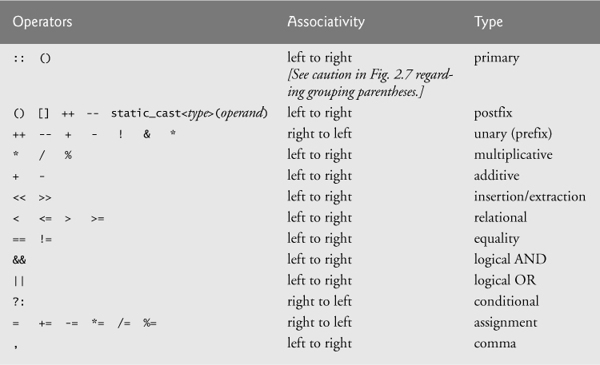
Figure 4Associativity Table
Link for image: - https://www.oreilly.com/library/view/c11-for-programmers/9780133439885/graphics/08fig05.jpg

RGB interfacing on Tinkercad

Circuit Design
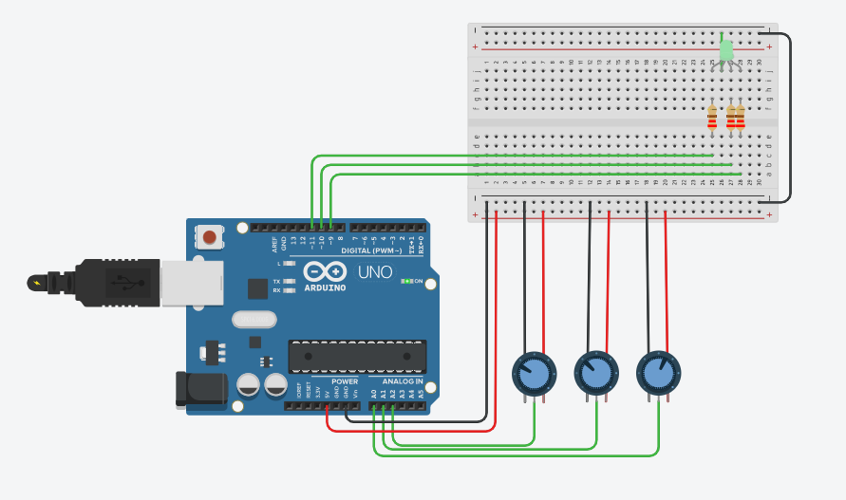
Figure 5RGB Interfacing Circuit Diagram

Simulation Result
https://www.tinkercad.com/things/1Elit1VaRJw-fabulous-luulia-wluff/editel?sharecode=78sJc9UUlyLqJQZMwmnWinzkuEYCBiPOEMVR5YRwhNE=

Code

void setup()
{
pinMode(9, OUTPUT);
pinMode(10, OUTPUT);
pinMode(11, OUTPUT);
pinMode(A0, INPUT);
pinMode(A1, INPUT);
pinMode(A2, INPUT);

}

void loop()
{
analogWrite(9 , ( analogRead(A0) / 4 ));
analogWrite(10 , ( analogRead(A1) / 4 ));
analogWrite(11 , ( analogRead(A2) / 4 ));
}

Size of Serial Registers in Atmega 328P
The size is 1 byte or 2 byte.

Frames in Ethernet
Frames of Ethernet range from 64 bytes to upto 1500 bytes

Prescalar
A prescalar is a counting circuit which reduces the frequency of an input signal by dividing the frequency by a prescaled value which is a power of 2. They can be used in timers, counters, ADC modules or analog inputs. Major use of prescalar is to write delay subroutines or to reduce CPU clock frequency for certain applications.

Simulator and Emulator
- Simulator
- Simulator works on the modeling of the system where each block is mimicked properly. The code runs through the proper methodology and presents the output.
- They can’t work with real time inputs
- They cannot be used for debugging.
- The host system cannot interact with the target system.
- Any changes in the hardware/target system cannot be reflected in simulation

- Emulators
- They do not copy the functionality of target system but rather interacts with the host system to give the output
- Majorly used for debugging.
- Real time inputs can be given.
- They use constant breakpoints to halt the processor and then copy its register, memory status values for displaying on the host system.
- Hence, they consume more time than actual run time of processor.
- Changes in the hardware/ target system cause a change in the emulator output.

